Parrot optimizer: Algorithm and applications to medical problems

Junbo Lian ^{1,2,3}, Guohua Hui ^{1,2,3}, Ling Ma ^{1,2,3}, Ting Zhu ^{1,2,3}, Xincan Wu ^{1,2,3}, Ali Asghar Heidari ⁴, Yi Chen ⁵, Huiling Chen ^{5*}

¹ College of Mathematics and Computer Sciences, Zhejiang A & F University, Hangzhou 311300
junbolian@qq.com, deliver1982@163.com, 2516453776@qq.com, 862640717@qq.com, 2303378787@qq.com
² Key Laboratory of Forestry Sensing Technology and Intelligent Equipment of Department of Forestry, Zhejiang A & F University, Hangzhou 311300
junbolian@qq.com, deliver1982@163.com, 2516453776@qq.com, 862640717@qq.com, 2303378787@qq.com
³ Key Laboratory of Forestry Intelligent Monitoring and Information Technology of Zhejiang Province, Zhejiang A & F University, Hangzhou 311300
junbolian@qq.com, deliver1982@163.com, 2516453776@qq.com, 862640717@qq.com, 2303378787@qq.com
⁴ School of Surveying and Geospatial Engineering, College of Engineering, University of Tehran, Tehran, Iran
as_heidari@ut.ac.ir
⁵ College of Computer Science and Artificial Intelligence, Wenzhou University, Wenzhou 325035, PR China
kenyoncy2016@gmail.com, chenhuiling.jlu@gmail.com
*Corresponding Author: Huiling Chen (chenhuiling.jlu@gmail.com)

The parrot optimizer (PO)
This section explains the overall background of the PO and the formulated optimization models.

Inspiration
The Pyrrhura Molinae, a well-liked parrot species, is a popular choice for pet owners owing to its attractive features, close bonding with its owners, and ease of training [54, 55]. Previous studies and breeding efforts have revealed that Pyrrhura Molinae exhibits four distinct behavioral traits: foraging, staying, communicating, and a fear of strangers [56, 57]. These behaviors, illustrated in Fig. 1 within real-world contexts, form the basis of our motivation for designing the PO.
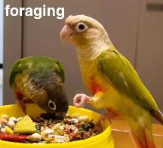 | 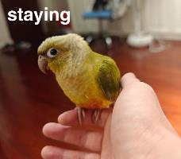 | 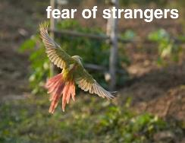 | 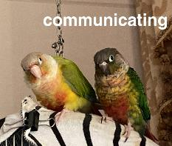
- foraging | (b)staying | (c) fear of strangers | (d) communicating
Fig. 1. Four behaviors of Pyrrhura Molinae
- The foraging behavior of domesticated Pyrrhura Molinae is fascinating, as individuals choose to forage in small groups where food is abundant [54]. They can find the food by heading toward it, utilizing their owner's location and the group's presence. They enhance their search using smell and visual hints.
- The staying behavior involves Pyrrhura Molinae perching randomly on various areas of their owner's body.
- These sociable birds produce distinctive calls to communicate within their group, serving both for social interaction and information spread.
- The natural fear of strangers, a common trait among birds, prompts Pyrrhura Molinae to move away from unfamiliar individuals and seek safety with their owners for protection [58].
- Importantly, the unpredictability of Pyrrhura Molinae behavior stresses the motivation for our design, as these four behaviors occur randomly in each individual during each iteration within domesticated flocks.

Mathematical model of PO

Population initialization
The initialization formulation for the proposed PO, considering a swarm size of $N$, maximum iterations of ${Max}_{iter}$, and search space limits of $lb$ (lower bound) and $ub$ (upper bound), can be shown as:
$X_{i}^{0}=lb+rand(0,1)⋅(ub-lb)$
where $rand(0,1)$ denotes a random number in the range [0, 1] and $X_{i}^{0}$denotes the position of the $i^{th}$ Pyrrhura Molinae in the initial phase.

Foraging behavior
During the foraging behavior in PO, they estimate the approximate location of food primarily by observing the food's location or by considering the owner's position, then they fly towards the respective location. Therefore, the positional movement follows the equation:
$X_{i}^{t+1}=(X_{i}^{t}-X_{best})⋅Levy(dim)+rand(0,1)⋅(1-\frac{t}{Max_{iter}})^{\frac{2t}{Max_{iter}}}⋅X_{mean}^{t}$
In Eq. (2), $X_{i}^{t}$ denotes the present location, while $X_{i}^{t+1}$ means the location of the succeeding update. $X_{mean}^{t}$ represents the average location inside the present population, and $Levy(D)$ denotes the Levy distribution, It is used to describe the flight of parrots.$X_{best}$ denotes the best position that has been searched from initialization to the current, and it also represents the host's current position. $t$ denotes the current number of iterations. $(X_{i}^{t}-X_{best})⋅Levy(dim)$ indicates movement based on one's position in relation to the owner, and $rand(0,1)⋅(1-\frac{t}{Max_{iter}})^{\frac{2t}{Max_{iter}}}⋅X_{mean}^{t}$ indicates observation of the position of the population as a whole to further target the orientation of the food. The process is depicted in Fig. 2.
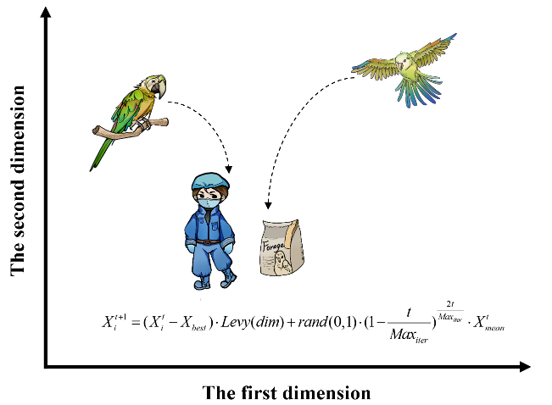
Fig. 2. The foraging behavior
The average location of the current swarm, is shown by $X_{mean}^{t}$, is attained using the formula shown in Eq. (3).
$X_{mean}^{t}=\frac{1}{N}\sum_{k=1}^{N}{X_{k}^{t}}$
The Levy distribution can be obtained based on rule in Eq. (4), where $γ$ is assigned the value of 1.5.
$\left\{\begin{aligned}&Levy(dim)=\frac{μ⋅σ}{{\left|v\right|}^{\frac{1}{γ}}} \\ &μ∼N(0,dim) \\ &v∼N(0,dim) \\ &σ=(\frac{Γ(1+γ)⋅\sin{(}\frac{πγ}{2})}{Γ(\frac{1+γ}{2})⋅γ⋅2^{\frac{1+γ}{2}}}​)^{γ+1}\end{aligned}\right.$

Staying behavior
Pyrrhura Molinae is a highly sociable creature, and its staying behavior primarily involves the sudden flight to any part of its owner's body, where it remains stationary for a certain period. This process is shown in Fig. 3. This process can be represented as:
$X_{i}^{t+1}=X_{i}^{t}+X_{best}⋅Levy(dim)+rand(0,1)⋅ones(1,dim)$
where $ones(1,dim)$ denotes the all-1 vector of dimension $dim$.$X_{best}⋅Levy(dim)$ denotes the flight to the host, and $rand(0,1)⋅ones(1,dim)$ denotes the process of randomly stopping at a part of the host's body.
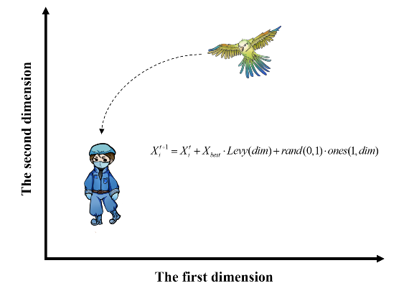
Fig. 3. The staying behavior

Communicating behavior
Pyrrhura Molinae parrots are inherently social animals characterized by close communication within their groups. This communication behavior encompasses flying to the flock and communicating without flying to the flock. In the PO, both behaviors are assumed to occur with equal probability, and the mean position of the current population is employed to symbolize the center of the flock. This process is shown in Fig. 4. This process can be represented as:
$X_{i}^{t+1}=\left\{\begin{aligned}&0.2⋅rand(0,1)⋅(1-\frac{t}{Max_{iter}})⋅(X_{i}^{t}-X_{mean}^{t}), P≤0.5 \\ &0.2⋅rand(0,1)⋅\exp{(}-\frac{t}{rand(0,1)⋅Max_{iter}}), P>0.5\end{aligned}\right.$
where, $0.2⋅rand(0,1)⋅(1-\frac{t}{Max_{iter}})⋅(X_{i}^{t}-X_{mean}^{t})$ denotes the process of an individual joining a parrot’s group to communicate and $0.2⋅rand(0,1)⋅\exp{(}-\frac{t}{rand(0,1)⋅Max_{iter}})$ denotes the process of an individual flying away immediately after communicating. Both behaviors are feasible and, as such, are implemented using a randomly generated $P$ within the range of [0, 1].
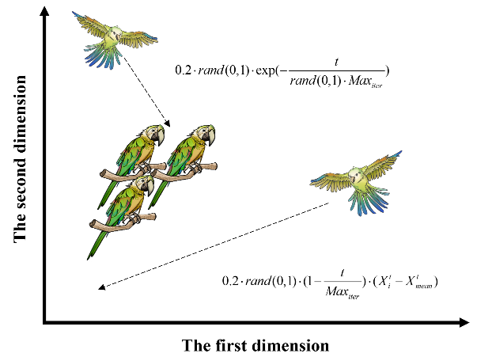
Fig. 4. The communicating behavior

Fear of strangers behavior
As a general rule, birds exhibit a natural fear of strangers, and Pyrrhura Molinae parrots are not an exception. Their behavior of distancing themselves from unfamiliar individuals and seeking safety with their owners in search of a secure environment is illustrated in Fig. 5, as described below:
$X_{i}^{t+1}=X_{i}^{t}+rand(0,1)⋅\cos{(}0.5π⋅\frac{t}{Max_{iter}})⋅(X_{best}-X_{i}^{t})-\cos{(}rand(0,1)⋅π)⋅(\frac{t}{Max_{iter}})^{\frac{2}{Max_{iter}}}⋅(X_{i}^{t}-X_{best})$
where $rand(0,1)⋅\cos{(}0.5π⋅\frac{t}{Max_{iter}})⋅(X_{best}-X_{i}^{t})$ shows the process of reorientating to fly towards the owner and $\cos{(}rand(0,1)⋅π)⋅(\frac{t}{Max_{iter}})^{\frac{2}{Max_{iter}}}⋅(X_{i}^{t}-X_{best})$ shows the process of moving away from the strangers.
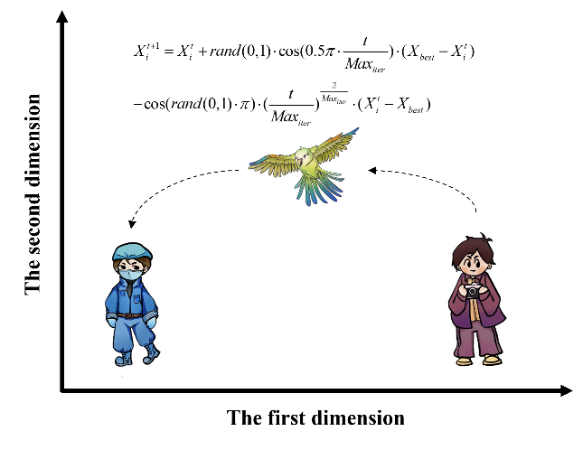
Fig. 5. The fear of strangers’ behavior

Pseudo-code of the PO algorithm
As per Algorithm 1, the PO optimization procedure begins by randomly generating a predefined set of candidate solutions, referred as the population. Utilizing a sequence of behaviors, PO's search strategy navigates locations near the optimal solution or where the best solution has been discovered. During the optimization process, each solution adapts its position dynamically, influenced by the best solution identified thus far in the PO algorithm. The search process in PO persists until the predetermined termination criterion is satisfied. The algorithm's complete structure, illustrated through pseudo-code in Algorithm 1 and visually in Fig. 6, is provided, offering a comprehensive roadmap for the entire optimization procedure, including its iterative steps and search strategies. PO leverages the advantages of both exploration and exploitation, enabling it to navigate the search space effectively while converging towards optimal solutions.
Algorithm 1: Pseudo-code of the PO algorithm
1: Initialize the PO parameters
2: Initialize the solutions' positions randomly
3: For i = 1:Max_iter do
4: Calculate the fitness function
5: Find the best position and worst position
6: For j = 1:N do
7: St = randi([1, 4])
8: Behavior 1: The foraging behavior
9: If St == 1 Then
10: Update position by Eq. (2)
11: Behavior 2: The staying behavior
12: Elseif St == 2 Then
13: Update position by Eq. (5)
14: Behavior 3: The communicating behavior
15: Elseif St == 3 Then
16: Update position by Eq. (6)
16: Behavior 4: The fear of strangers’ behavior
17: Elseif St == 4 Then
18: Update position by Eq. (7)
19: End
20: End
21: Return the best solution
22: End

Fig. 6. Flowchart of PO algorithm

